**Demographic Survey Questions**

1. What year of college are you in? (Freshman, Sophomore, Etc.)
2. What is your racial identity
3. What is your academic major and minor?
4. When was the last time you voted in a federal or state election?
5. What are your plans after graduation?
6. What is your sex?

**Conservative Profile Questions**

1. Please indicate the degree to which you feel you lean conservative from 1 (slightly conservative) to 5 (Extremely conservative). ***Responses measured on a Likert scale from 1 to 5***
2. Please imagine that you are in a voting booth and asked to vote for one of the two candidates listed below to become the next President of the United States. Below are the two candidates as well as a brief profile discussing their views on policy and personal issues. Please read each candidates profile carefully and then choose who you would vote for of the two candidates
3. Candidate Comparison

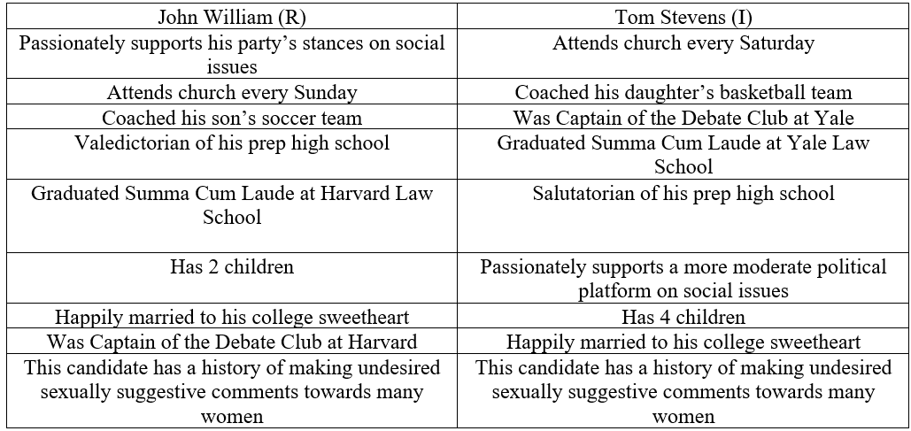

**Liberal Profile Questions**

1. Please indicate the degree to which you feel you lean conservative from 1 (slightly liberal) to 5 (Extremely liberal).

***Responses measured on a Likert scale from 1 to 5***

1. Please imagine that you are in a voting booth and asked to vote for one of the two candidates listed below to become the next President of the United States. Below are the two candidates as well as a brief profile discussing their views on policy and personal issues. Please read each candidates profile carefully
2. Candidate Comparison

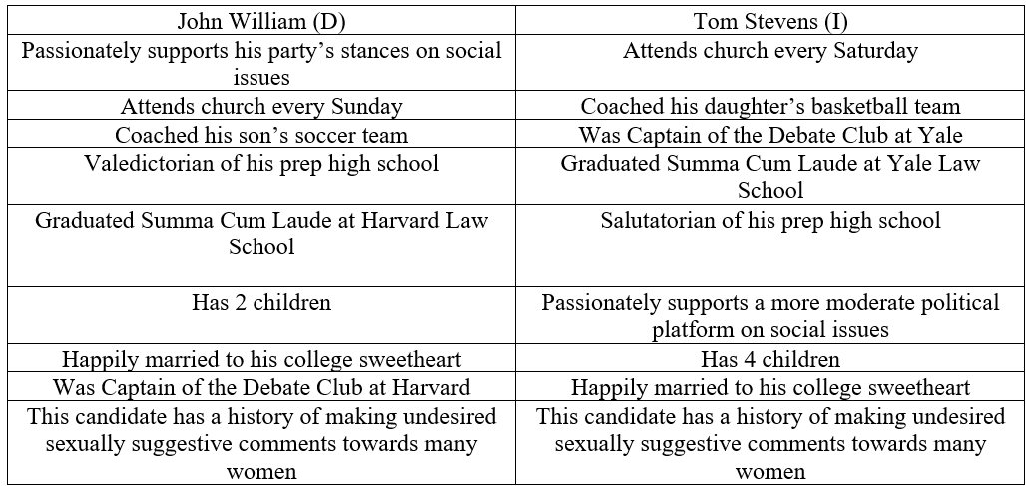

**Every Participant Measures**

**Conservatism Scale (0-100 Thermometer)**

Asks participants questions regarding how they feel about certain topics including abortion, welfare benefits, taxes, immigration, limited government, military and national security, religion, gun ownership, traditional marriage, traditional values, fiscal responsibility, business, the family unit and patriotism.

**Degree of Forgiveness (0-9 Likert Scale)**

To what extent do you agree that the candidate accused of sexual harassment be forgiven for their actions?

**Degree of Believability (0-5 Likert Scale)**

To what degree would you judge your candidate to be believable if they were to apologize and say that they have become a changed man?

**Comfort (1-7 Likert)**

How comfortable you are with you choice of candidate?

**Party Support (1-7 Likert)**

How likely do you believe your candidates own party members will vote for him?

**Opposing Party Support (1-7 Likert)**

How likely do you believe the opposing party members will vote for your candidate?

**Party Values (1-5 Likert)**

How much you believe that your candidates values represent his party's values?

**Individual Support (1-5 Likert)**

To what degree would you support this person in their bid to win an elected office?

**Better Choice (1-5 Likert)**

To what degree you believe that your candidate is a better choice than his opponent?

**Candidate Friendliness (1-5 Likert)**

To what degree you believe that your candidate is a better choice than his opponent?

**Candidate Intelligence (1-5 Likert)**

How smart do you think your candidate is?

**Likelihood of Friendship (1-7 Likert)**

How likely is it that you would be friends with this person?

**Candidate Morality (1-7 Likert)**

How moral do you find your candidate?

**Me Too Support (1-7 Likert)**

Please indicate your level of support for the #MeToo movement that seeks to allows victims to speak out against their perpetrators?

**Every Participant Question**

If you had to choose, which political affiliation do you tend to lean towards?

After reading each candidate's profile, which would you most likely vote for?

Which candidate was accused of sexual assault?

Do you understand the debriefing form and the purpose of the study?

Thank you for participation in this study! At this time would you like to receive credit for this study? If yes, you will be directed to a second study where you can place your name so that we can assign credit. Your answer’s given in the study will not be matched with your name and will be kept confidential